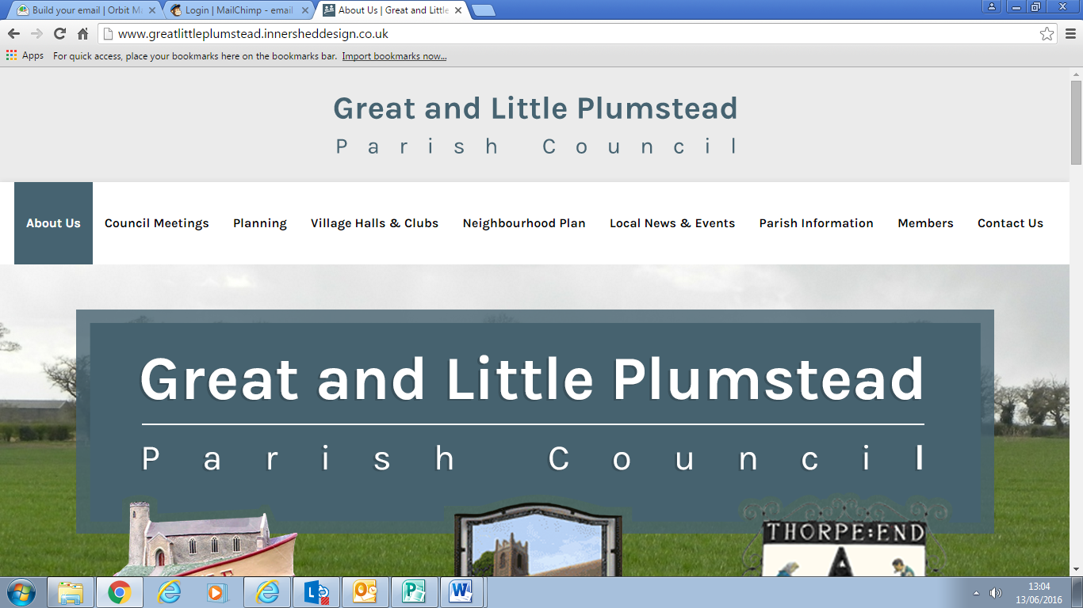

**A Meeting of Great & Little Plumstead Parish Council was held on Monday 8th July 2024 at 7.00pm at Little Plumstead Village Hall**

**PRESENT: Mr J Wiley (Chairman)**

**Mr A Cawdron Mr R Rice**

**Mr G Edwards Mr R Heath**

**Mrs J Jones Mr P Knowles**

**Mrs T Scott (Clerk)**

* **Police Report** – April 24 - Thorpe End – 2, Little Plumstead – 5, Great Plumstead - 0
* **County Councillor Report** – No report received.
* **District Councillor Report** – Councillor Harvey confirmed that he has his member’s grant of £1000 against this year and is open to suggestions. The work on the Saffron Homes development, Green Lane East, is due to start late summer, Councillor Harvey is continuing to chase Broadland District Council, the NHS and Saffron Homes for regular updates. Saffron Homes confirmed that third party approvals for the first phase of site infrastructure are still being worked through, should be ready for October. The Plumstead Road improvements will be delivered separately at a later date which is still to be confirmed. Broadland District Council have requested infiltration testing as well as further lighting details on the Little Plumstead Hospital planning application. The Smee Lane development was called in to the planning committee as the application does not sit in line with the Neighbourhood Plan on a number of points. BDC and SNC will be rolling out new Community Employability Projects which are being funded by the government UK Shared Prosperity Fund. This is to support people to overcome barriers to employment and training. Two new Financial Wellbeing co-ordinators will be employed who will be linked to the Help Hub. The Town and Parish Council Forum meetings continue to be held online monthly. These meetings are recorded now and will be circulated. Nominations are now open for the BDC Community at Heart Awards 2024, nominations close on 29th August and will be presented on 17th October. More information on the website. A new First Bus Green Line bus route 17 started running on 23 June 2024 which will serve the Broadland Gate Business Park. *The Councillors confirmed that the Nutrient Neutrality document isn’t viewable, it was believed this is because it has been recently changed.*
* **Public Participation –** Fly tipping is happening at Sandhole Lane, Little Plumstead. This will be reported and carries a fine. Pot holes are forming along Middle Road, Great Plumstead which need to be reported.

**AGENDA**

1. **APOLOGIES FOR ABSENCE**

Councillor Vincent, Bullen, Carty and Claxton

1. **DECLARATIONS OF INTEREST**

None

1. **TO APPROVE AS A TRUE RECORD THE MINUTES OF THE MEETING HELD ON 10th JUNE 2024**

Approved. Proposed – Councillor Heath. Seconded – Councillor Edwards. All agreed.

1. **TO REPORT MATTERS ARISING FROM THE MINUTES NOT ON THE AGENDA: FOR INFORMATION ONLY**

No update from the Delta Fire project for a wind turbine. The unused speed sign on Low Road has been reported to Broadland DC and we have asked if this can be moved to somewhere in the Parish. Cripps have confirmed that they have requested to have a tree survey undertaken in the next couple of weeks instead of waiting until September. The broken manhole cover over on Middle Road, by the footpath has been reported again this week.

1. **TO RECEIVE CORRESPONDENCE** 
   1. Church Road, Great Plumstead – Speeding – Councillor Heath will see if the SAM2 sign can be used.
   2. Water Lane, Great Plumstead – Pathway Cutting – Discussed in the meeting.
   3. Town & Parish Forum – 9th July – Circulated to the Councillors
   4. Highways – VAS possible locations – Discussed in the meeting.
   5. Cash & Carry, Old School Road – Parking and delivery issues – A number of complaints were received due to the inconsiderate parking on Old School Road and Witton Lane which meant that pedestrians were unable to use the pathway. Together with complaints about delivery trucks which had completely blocked Witton Lane and obstructed Old School Road. The Brethren have been contacted and they will speak to their members and the delivery companies to ensure that this does not happen.
   6. Woodland, Hospital Road – The Walled Garden has put together a list of the trees which are overhanging the walls, these have been forwarded to Cripps for them to investigated. Together with the issues with the hedge along Hospital Road.
   7. Broadland & South Norfolk Design Code – Online workshop – Scheduled for Monday 22nd July and circulated to the Councillors.

1. **TO CONSIDER PLANNING APPLICATIONS**

The Parish Council made the following comments on planning applications:

|  |  |  |  |
| --- | --- | --- | --- |
| 2024/1798 | The Nurseries, Smee Lane, Great Plumstead | Details of condition 16c of 20180193 – archaeological mitigation post excavation assessment | No objection |
| 2024/1799 | Land North of Smee Lane, Great Plumstead | Details reserved by condition 12 of 20180193 – Phase 1 (Desk based) contaminated land and geotechnical desk study, contaminated land & geotechnical assessment, demolition survey | No objection |
| 2024/1532 | Community Shop, Old Hall Road, Little Plumstead | Proposed Community Workshop | No objection. |
| 2024/1368 | The New House, Smee Lane, Great Plumstead | Build of double car shed with pitched roof | No objection. Please note that no planning application form is listed amongst the 10 documents. It is assumed that vehicles will be able to turn to exit to the Lane and that surface water discharge from the roof of the car port and driveway (future surfacing currently unknown) is correctly managed. |
| 2024/0068 | Braemar House, Reeves Corner, Great Plumstead | Outline planning permission for 1 single dwelling with detached garage and new access including access, appearance, layout and scale with landscaping reserved | No objection. The revised proposal places the building much closer to the neighbouring boundary to the extent that e.g. scaffolding could not be erected without neighbour consent. This appears an unnecessary constriction and we would suggest a slight relocation to open up the gable chimney elevation to allow easier construction and future maintenance. We note the extension of time granted to allow Nutrient Neutrality credits to be identified. The parking allowances shown are now not in accordance with Policy 2 of the Neighbourhood Plan and similarly refuse arrangements are not shown. |
| 2024/1769 | Land at Green Lane East, Little Plumstead | Reserved matters of layout, scale, appearance and landscaping in relation to the erection of a 92-unit extra care independent living facility (use class C3) and associated development | There is no layout plan for the second storey of the building. There are no medical waste arrangements identified. The surface water arrangements are not identified. No attention has been paid to the noise and pollution levels from the NDR included within the application. |

1. **TO DISCUSS PARISH PROJECTS**
   1. **TO DISCUSS THE CURRENT SITUATION WITH THE GREAT PLUMSTEAD RECREATIONAL GROUND PROJECT**

Four tenders were received and opened in accordance with the Standing Orders. All four tenders were above the budget, phasing the project will be discussed. The Parish Council will be meeting with the tenders which met the criteria, this is open to all the Parish Councillors. The Letter of Intent will be agreed before the end of July 2024.

* 1. **TO DISCUSS THE QUOTE RECEIVED TO SURRENDER THE LEASES AT GREAT PLUMSTEAD RECREATIONAL GROUND**

Only one quote was received ahead of the meeting, the Councillors agreed to wait for the others to come in.

* 1. **TO DISCUSS THE FUTURE OF THE GREAT PLUMSTEAD TENNIS COURTS**

If the Parish Council takes on the Tennis Courts there will be a cost payable to the current tenant for the fixtures and fittings. The respraying which has just been done costs approximately £1800 with a resurfacing within the region of £18,000 - £30,000. The resurfacing will need to be done in the near future. It was agreed that any future owner would not have such a long lease. Potentially a footpath would need to be put in from the carpark to the tennis courts. The Parish Council will wait to hear from the current tenant and what they plan to do.

* 1. **TO DISCUSS THE FULL PARISH TREE SURVEY QUOTES RECEIVED**

Quotes were not received in time. The works from the tree survey at Rosebery Fields were not undertaken before the transfer happened.

* 1. **TO DISCUSS THE UPCOMING DEADLINE OF THE PUBLIC RIGHTS OF WAY**

The deadline to ensure that public rights of way are registered properly is approaching. The Parish Councillors identified that the Thorpe End Woodland walk and the Glade Woodland is not shown on the current plan.

* 1. **TO DISCUSS THE QUOTE RECEIVED FOR THE PLUMSTEAD GREEN BENCH WORKS**

Quote received from RJW Carpentry for the works to rub down bench and re-stain together with replacing 3 bricks to base. Cost £382.00. Proposed – Councillor Cawdron. Seconded – Councillor Jones. All agreed.

* 1. **TO DISCUSS AND AGREE THE MEMORIAL BENCH FOR GREAT PLUMSTEAD RECREATIONAL GROUND**

The Clerk had gathered in a number of quotes for a four seater bench for the Great Plumstead Recreational Ground. The Parish Council agreed to go with NBB at a cost of £610. Proposed – Councillor Knowles. Seconded – Councillor Heath. All agreed.

* 1. **TO DISCUSS THE QUOTE RECEIVED FOR THE REPAIR WORKS TO LITTLE PLUMSTEAD PLAY AREA**

Quote received from RJW Carpentry for the works to Little Plumstead Play Area. At a cost of £315. Proposed – Councillor Heath. Seconded – Councillor Rice. All agreed.

1. **TO DISCUSS THE WORKS UNDERTAKEN TO THE HEDGE AT WATER LANE, GREAT PLUMSTEAD**

The works undertaken to the hedge which runs from Water Lane, Great Plumstead to Salhouse Road, Little Plumstead was undertaken by Highways. The landowners nor the Parish Council were aware of these works being planned. Highways confirmed that a bird nesting survey was conducted prior to any works being carried out. Councillor Rice suggested that the Parish Council could take possession of the hedge as an agency of Highways under an agency agreement. The Clerk will speak to Highways to see if this is possible.

1. **TO DISCUSS PROJECTS FOR THE PARISH PARTNERSHIP BID 2025/26**

Councillor Cawdron put forward the pathway from the Railway footpath, Thorpe End to the Thorpe End Village Hall. The Clerk will put this to Highways to see if this is possible.

1. **TO DISCUSS POSSIBLE SITES FOR THE VAS SIGN WITHIN THE PARISH**

Broad Lane, Great Plumstead. Need to check to see if the sign on Low Road, Great Plumstead still works.

1. **TO AGREE PAYMENTS IN ACCORDANCE WITH THE BUDGET AS LISTED**

The following accounts were agreed in accordance with the Budget:

**Payments**

|  |  |  |  |  |
| --- | --- | --- | --- | --- |
| Bank Balance | | Nat West | **£22,479.25** | 28.06.2024 |
| Bank Balance | | Scottish Widows | **£41,501.55** | 31.05.2024 |
| Bank Balance | | Broadland Deposit Account | **£330,308.59** | 31.03.2024 |
| Payments |  |  |  |  |
|  |  |  |  |  |
| T Scott |  |  | Monthly payment | £1,472.80 |
| HMRC |  |  | Monthly Payment | £105.74 |
| Norfolk Pension Scheme | | | Monthly payment | £428.32 |
|  |  |  | **TOTAL** | **£2,006.86** |
| Receipts |  |  |  |  |
| Thorpe St Andrew - U7 | | | Football Hire | £60.00 |
|  |  |  | **TOTAL** | **£60.00** |
| **Outstanding Cheques** | | |  |  |
| NCSL |  |  | Sandhole Lane clearance | £556.17 |
| St David's Church TE | |  | Hall Hire | 36.00 |
| Norfolk Pension Scheme | | | Monthly Payment | 428.32 |
| J Cator |  |  | Hire - Sandhole Lane | 173.31 |
| RJW Carpentry | |  | Padgate - Repairs to trim trail | 450.00 |
| Jan Roomes | |  | Internal Auditor | 85.00 |
| CAN |  |  | Play Area Training | 60.00 |
|  |  |  | **TOTAL** | **£1,788.80** |
| **Current Account Balance** after above payments made and **outstanding cheques cleared** will be approximately | | | |  |
|  |  |  |  | **£18,743.59** |
| * already included in the accounts stated above | | |  |  |

Proposed – Councillor Jones. Seconded – Councillor Edwards. All agreed.

|  |  |  |  |  |
| --- | --- | --- | --- | --- |
| Bank Balance | | Unity Bank | **£55,723.45** | 30.06.2024 |
| Payments | |  |  |  |
| Canham Engineers | |  | Great Plumstead Project | £2,916.00 |
| Innershed | |  | Hosting of website | £238.80 |
| Unity Bank | |  | Service Charge | £19.20* |
|  |  |  | **TOTAL** | **£3,154.80** |
| Receipts |  |  |  |  |
|  |  |  | **TOTAL** | **£0.00** |
| **Payments Awaiting Authorisation** | | |  |  |
|  |  |  | **TOTAL** | **£0.00** |
| **Current Account Balance** after above payments made and **outstanding cheques cleared** will be approximately | | | |  |
|  |  |  |  | **£52,568.65** |
| * already included in the accounts stated above | | | |  |

Proposed – Councillor Knowles. Seconded – Councillor Heath. All agreed

* 1. **TO DISCUSS THE ALLOTMENT FINANCES FOR THE NEXT YEAR**

The Parish Council has to give a year’s notice of any raise in allotment rents. The Clerk will look at what other council’s offer and charge for their allotments.

1. **TO DISCUSS WHAT ITEMS SHOULD GO ONTO SOCIAL MEDIA THIS MONTH**

Rights of Way deadline.

1. **TO CONFIRM THE DATE AND TIME OF THE NEXT MEETING OF GREAT AND LITTLE PLUMSTEAD PARISH COUNCIL**

The date of the next meeting is Monday 9th September 2024 at 7.00pm at Great Plumstead Village Hall

1. **TO RECEIVE ITEMS FOR THE NEXT AGENDA**

Allotments

Water Lane – Salhouse Road Footpath

Great Plumstead Recreational Ground – Lease surrenders

There being no further business the meeting closed.

Signed: Chairman Date: