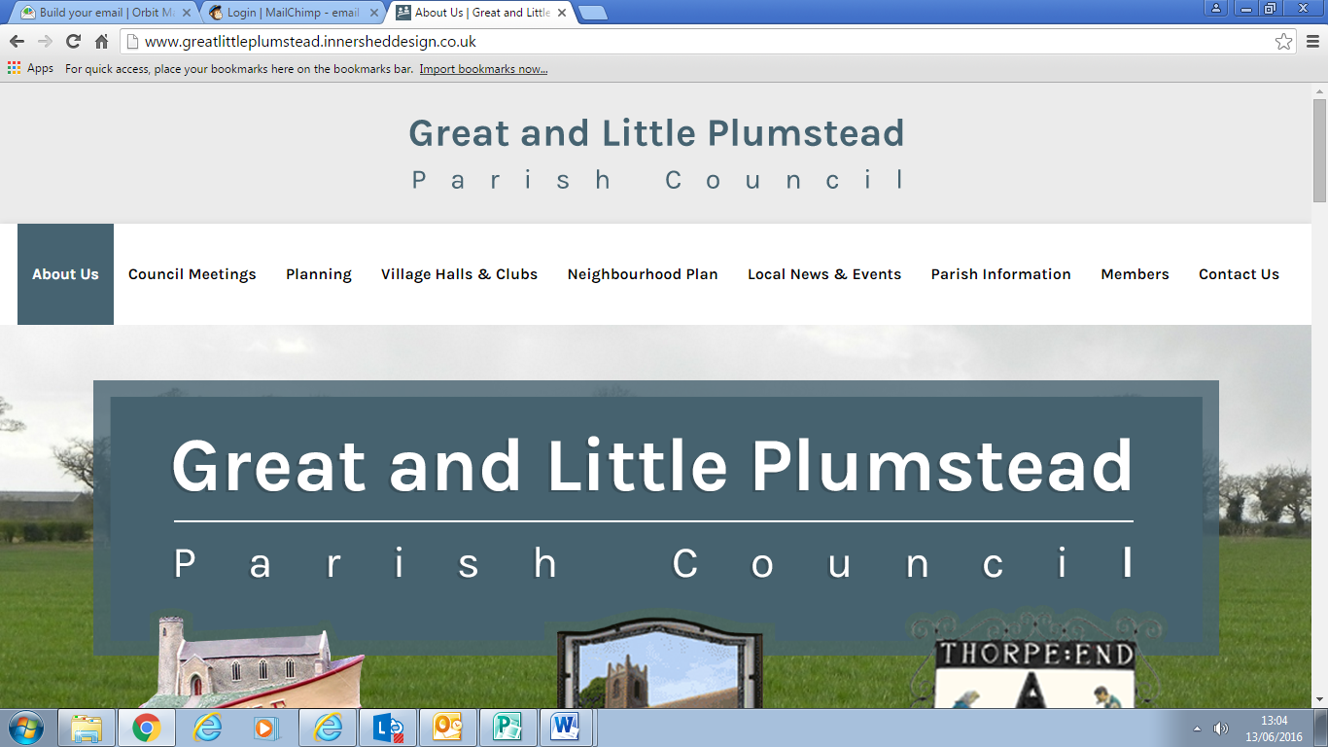**GREAT AND LITTLE PLUMSTEAD**

**PARISH COUNCIL**

**To Members of the Council**

You are hereby summoned to attend the budget and finance meeting which will be held at Octagon Offices, Manor Farm, Little Plumstead on Monday 6th January 2025 at 6.30pm

**A G E N D A**

1. To discuss the Clerk’s Salary
2. To discuss the budget for the 2025/2026 financial year
3. To discuss the proposed precept
4. To discuss whether the Natwest Account is needed now

**Mrs T Scott**

**Clerk to the Council**

**27th December 2025**